Informal Runoff/Excel Lab

(Due Thursday, March 12th, 2015)

Runoff Hydrograph Calculator

Write an Excel routine for determining peak discharge using both the Rational and SCS Triangular Hydrograph methods. The routine should include

- A function for determining area-weighted curve numbers or runoff coefficients
- A function for interpolating between rainfall intensities at two different durations
- A plot of the hydrographs from both methods on the same graph
- A plot showing the determination of the curve number

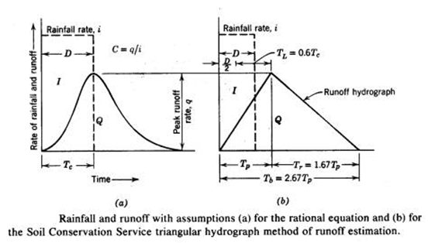

Rational Formula

q = CiA

Where q = peak flow (ft³/sec)
i = rainfall intensity (in/h) for the design return period and for a duration equal to the
“time of concentration” of the watershed.
A = watershed area in acres
C = runoff coefficient, ratio of the peak runoff rate to the rainfall intensity, dimensionless

Kirpich Formula

T_{c} = 0.0078 L^{0.77}S^{-0.385}

where T_{c} = time of concentration in minutes.
L = maximum length of flow (ft)
S = the watershed gradient (ft/ft )or the difference in elevation between the outlet and the most remote point divided by the length L.

SCS Lag Formula

T_{c} = 0.00526 L^{0.8}(1000/CN – 9)^{0.7} S^{-0.5}

where L = watershed length (ft)
S = watershed slope (ft/ft)
CN = curve number

SCS Triangular Hydrograph Method

q = 0.0021QA/T_{p}

where Q = runoff volume in mm depth (from the curve number)
q = runoff rate in m³/s
A = watershed area in ha.
T_{p} = time of peak in hours

In this method, the “time to peak” does not equal the time of concentration as in the rational method, in this method time to peak T_{p} equals

T_{p} = D/2 + T_{L} = D/2 + 0.6T_{c}

Where T_{p} = time to peak (hours)
D = duration of excess rainfall
T_{L} = time of lag
T_{c} = time of concentration

It is assumed that the total time of flow is 2.67 T_{p} and the recession time of the hydrograph is 1.67 T_{p}.

Time of concentration is calculated using the SCS Lag formula

