Lab 03 (Due Thursday, February 5th, 2015)

Lab 03: Soil Texture Calculator

Write an Excel routine for determining soil textural class given percent sand and percent clay, and show the point on the textural triangle in the file provided.

- Soils with more than 30% clay are clays.
- Soils with 20 - 30% clay are clay loams.
- Soils with less than 20% clay are loams unless they have more than 80% sand.
- Soils with more than 80% sand are sands.
- Soils with more than 50% sand are sandy.
- Soils with more than 50% silt are silty.
- A silty loam is called a silt loam.

Percent Sand | Percent Clay | Percent Silt | Soil Texture
44 | 33 | 27 | Clay

Think of possible entry errors and add error traps; flag negative numbers, for example.

Turn in your excel file along with your report.
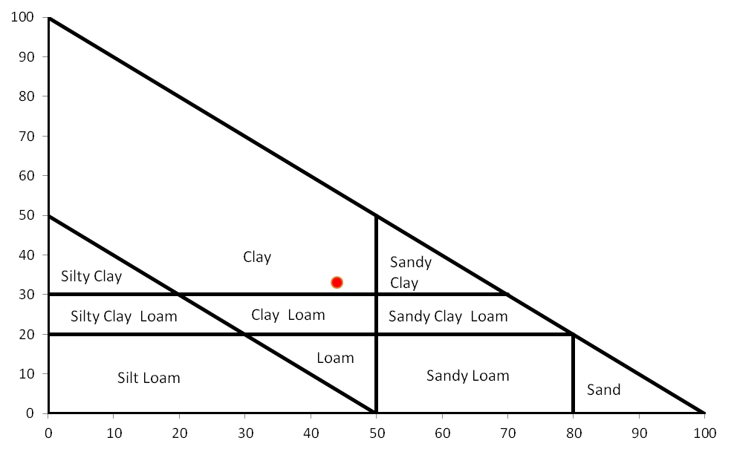

VBA Built-in Data Types
Data Type | Bytes Used | Range of Values
Boolean | 2 | True or False (Positive or Negative)
Integer | 2 | -32,768 to 32767
Long | 4 | -2,147,483,648 to 2,147,483,647
Single | 4 | -3.402823E38 to 1.401298E45
Double (negative) | 8 | -1.79769313486232E308 to -4.94065645841247E-324
Double (positive) | 8 | 4.94065645841247E-324 to 1.79769313486232E308
Currency | 8 | -922,337,203,685,477.5808 to 922,337,203,685,477.5807
Date | 8 | 1/1/100 to 12/31/9999
String | 1 per character | Varies according to the number of characters
Object | 4 | Any defined object
Variant | Varies | Any data type
Used defined | Varies | Varies

