Lab 01 (Due Tuesday, January 20th, 2015)

Preparing a Formal Laboratory Report

The main objective of this laboratory is to prepare a formal laboratory report using the template provided. The report will be based on a simple area determination.

Determine the area of the field shown below in both acres and hectares.

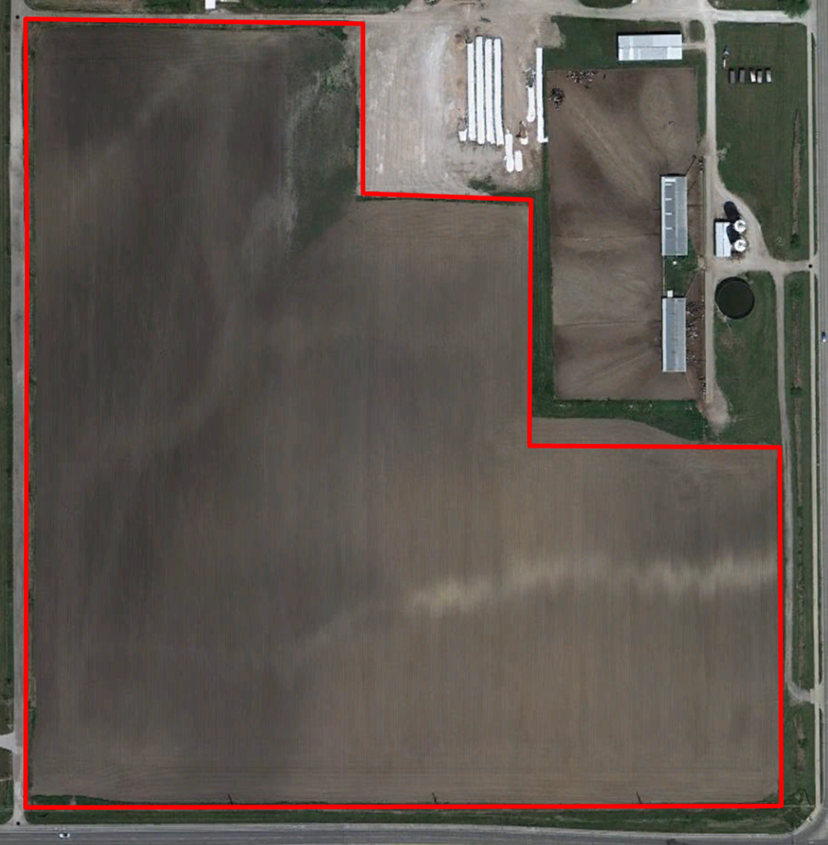
Figure 1. Aerial view of field.

Table1. Coordinates of field boundary.
Long/Lat Coordinates
1 | -88.223664 | 40.0868791
2 | -88.22151678 | 40.0868791
3 | -88.22151679 | 40.08644101
4 | -88.22044318 | 40.08644101
5 | -88.2204432 | 40.08561961
6 | -88.21915488 | 40.08561961
7 | -88.21915495 | 40.08370848
8 | -88.223664 | 40.083703
9 | -88.223664 | 40.08561961
Local Origin | -88.223664 | 40.083703

Write a report that describes what you have done and that provides the results of your analysis. Includes any tables and figures that you deem appropriate.

