TSM 352 HOMEWORK ASSIGNMENT 04

Due Monday, February 23rd at 11:59 pm

1) Using the tutorial you created for Lab 4, or otherwise, create a soil and satellite image overlay map for the field shown below. Indicate the soil name and area for each soil polygon.

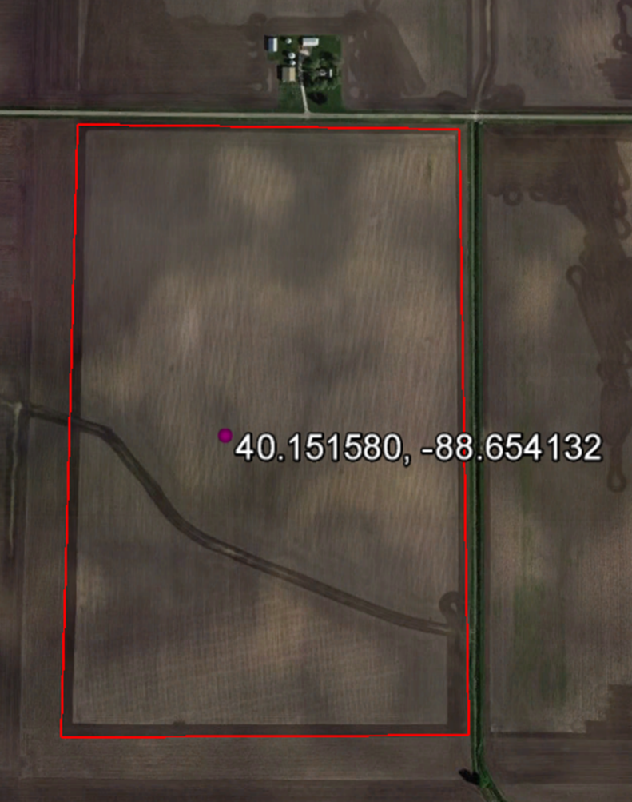

2) Determine the volume of water removed from the field above, when the water table falls from the ground surface to a meter below the surface.

